**Experiment-4**

**Aim:** Improvement of voltage profile at a load bus using a shunt capacitor.

**Simulink Blocks Required**

1. AC voltage source, single phase, 50 Hz
2. Pi section transmission line (R=0.037 Ohms/km, L=0.97347 mH/km, C=11.984 nF/km, total length= 300 km, 6 sections of 50 km each, rated line to line voltage is 400 kV, per phase rating is 230.94 kV)
3. R element representing a load (R=114 Ohms)-1 No.
4. C element for a shunt capacitor- 1No. (C=22.223 μF)
5. Single phase breaker-1No
6. Breaker control block-1No
7. Voltage and current measurement blocks
8. RMS calculation blocks
9. Display block
10. Powergui block

**Software Used**

MATLAB 2018a

**Theory**

Shunt capacitor is used to improve the power factor of the system. An inductive load absorbs reactive power due to the inductive component. This causes the voltage at load to dip in addition to the resistive voltage drop static shunt capacitors are installed near the load terminals, in factory substations in receiving substations etc. to provide leading VAR & thus to reduce the line current & total KVA loading of the substation. By using shunt capacitor line drop is reduced & voltage regulation is improved.

It may be noted that reactive power flows only due to difference in voltage level. If we make sending end voltage and receiving end voltage equal then there is no reactive power absorbed by load and all the reactive power absorbed by transmission line.

Shunt capacitors are switched in when KVA demand on the distribution system rises & voltage of the bus drops.

*Q generation < Q absorption*

*Q generation > Q absorption*

*Q generation = Q absorption*

The advantages of Shunt capacitors are low costs. And Flexibility of installation & operation. And the Disadvantage of Shunt capacitor is Reactive power is proportional to square of Voltage. So reactive power is reduced at low voltage when it is likely to be needed the most.

**Procedure:**

1. Build a SIMULINK model as shown in Circuit diagram.
2. Set the value of the ac voltage source to 326.598 kV peak & note down the input and output voltage. The load resistance is taken as 114 Ohms. Take the compensating shunt capacitor value to be 22.223 μF.
3. After about 4 seconds of simulation run time, the breaker will close contacts connecting the shunt capacitance.
4. Note down change in output voltage.
5. Repeat same for other value of voltages.
6. Calculate the Voltage regulation of line with Capacitor and without capacitor.

**Circuit Diagram**

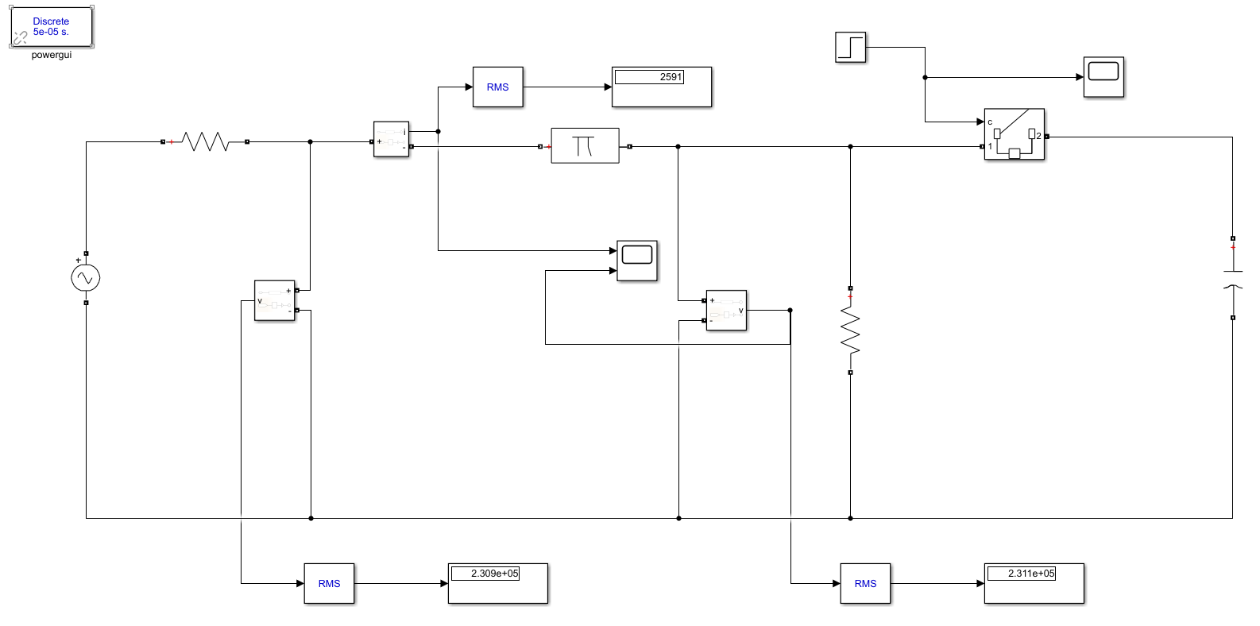

**Observation Table**

|  |  |  |  |  |  |
| --- | --- | --- | --- | --- | --- |
| **S.No** | **Vs**  **(KV)** | **WITH CAPACITOR** | | **WITHOUT CAPACITOR** | |
| **Load Current, IL (A)** | **VR (KV)** | **Load Current, IL (A)** | **VR (V)** |
| 1. | 230.9 | 2591 | 231.1 | 2477 | 24.77 |
| 2. | 238.0 | 2671 | 238.2 | 2553 | 25.53 |
| 3. | 245.1 | 2750 | 245.3 | 2629 | 26.29 |
| 4. | 252.2 | 2829 | 252.3 | 2705 | 27.05 |
| 5. | 259.2 | 2909 | 259.4 | 2781 | 27.81 |

**Graphs**

**1. Vs = 230.9 KV**

**WITH CAPACITOR**

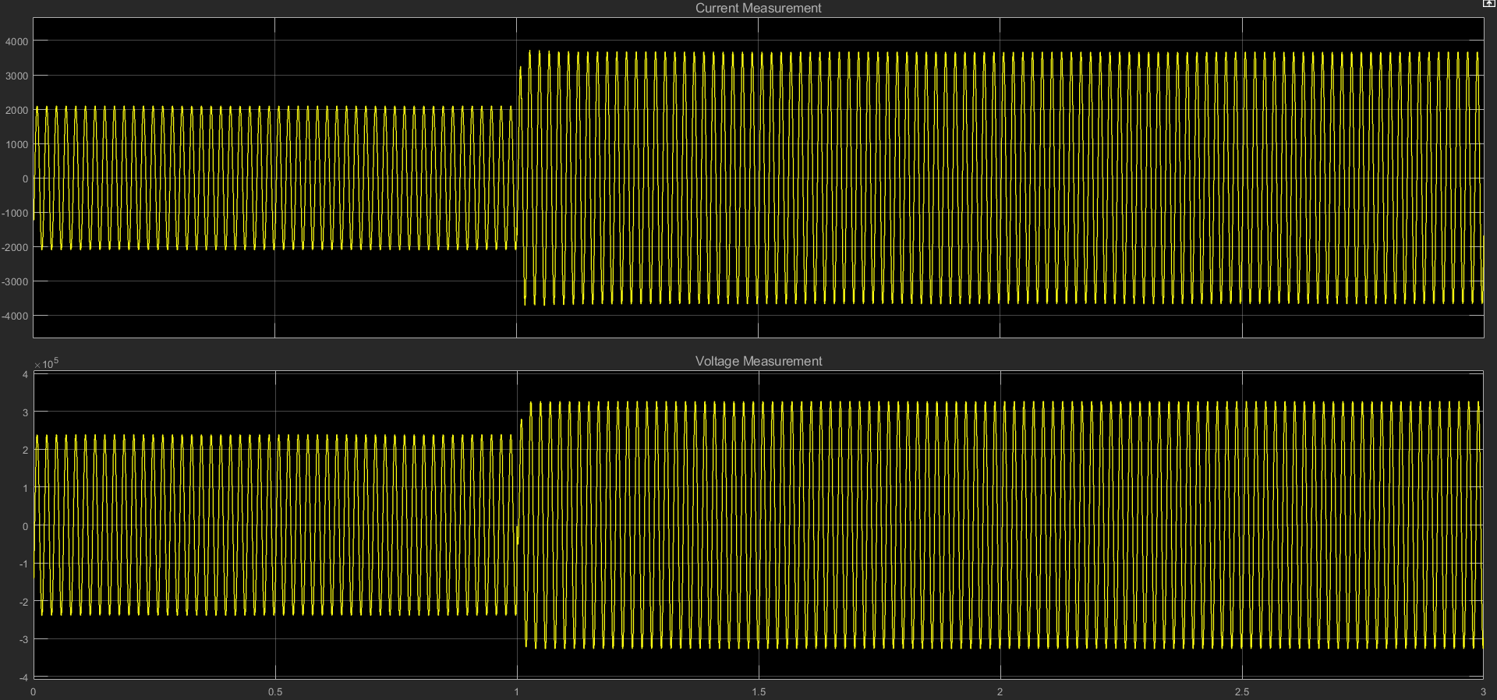

**WITHOUT CAPACITOR**

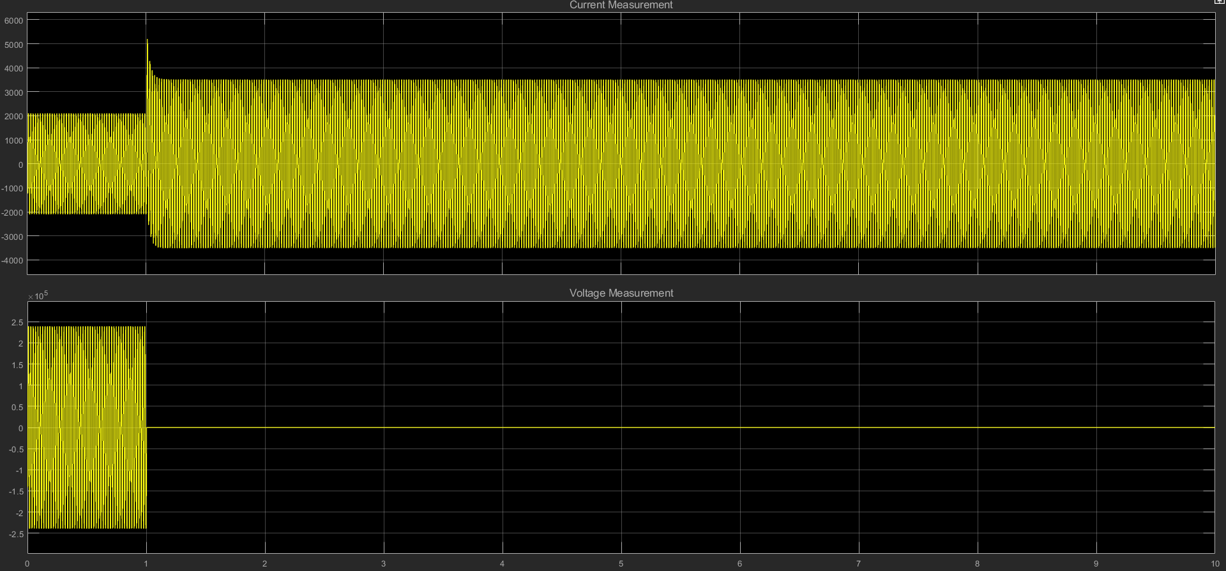

**2. Vs = 238.0 KV**

**WITH CAPACITOR**

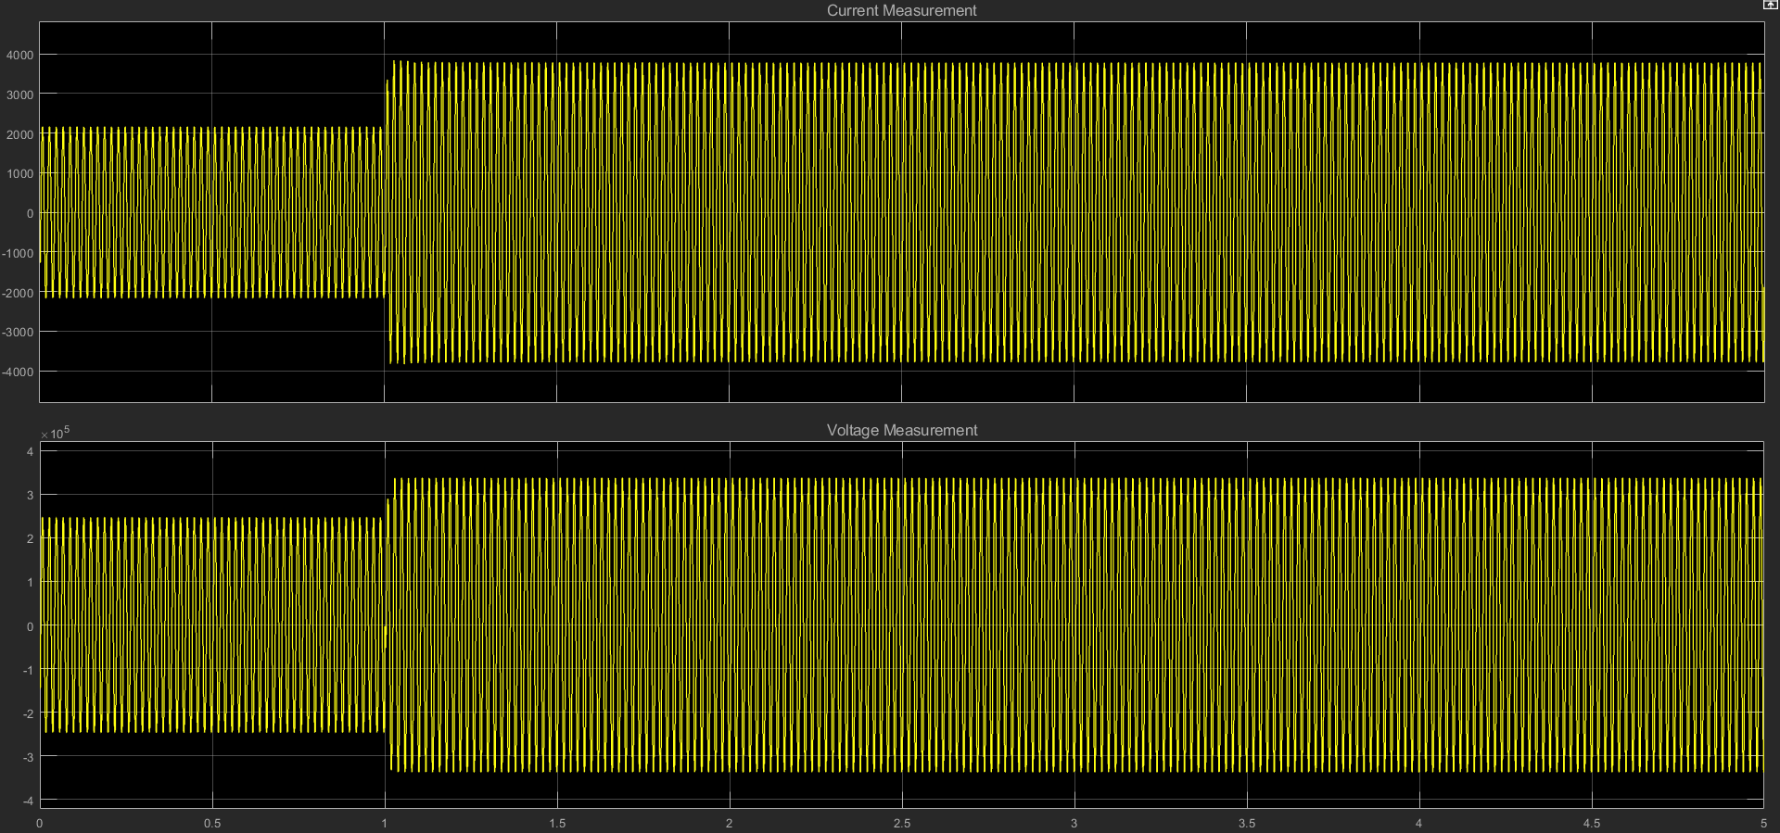

**WITHOUT CAPACITOR**

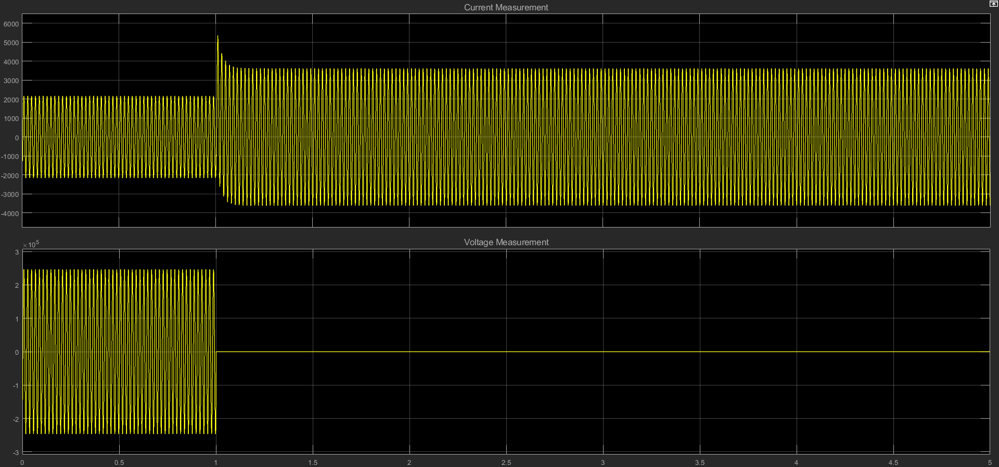

**3. VS = 245.1 KV**

**WITH CAPACITOR**

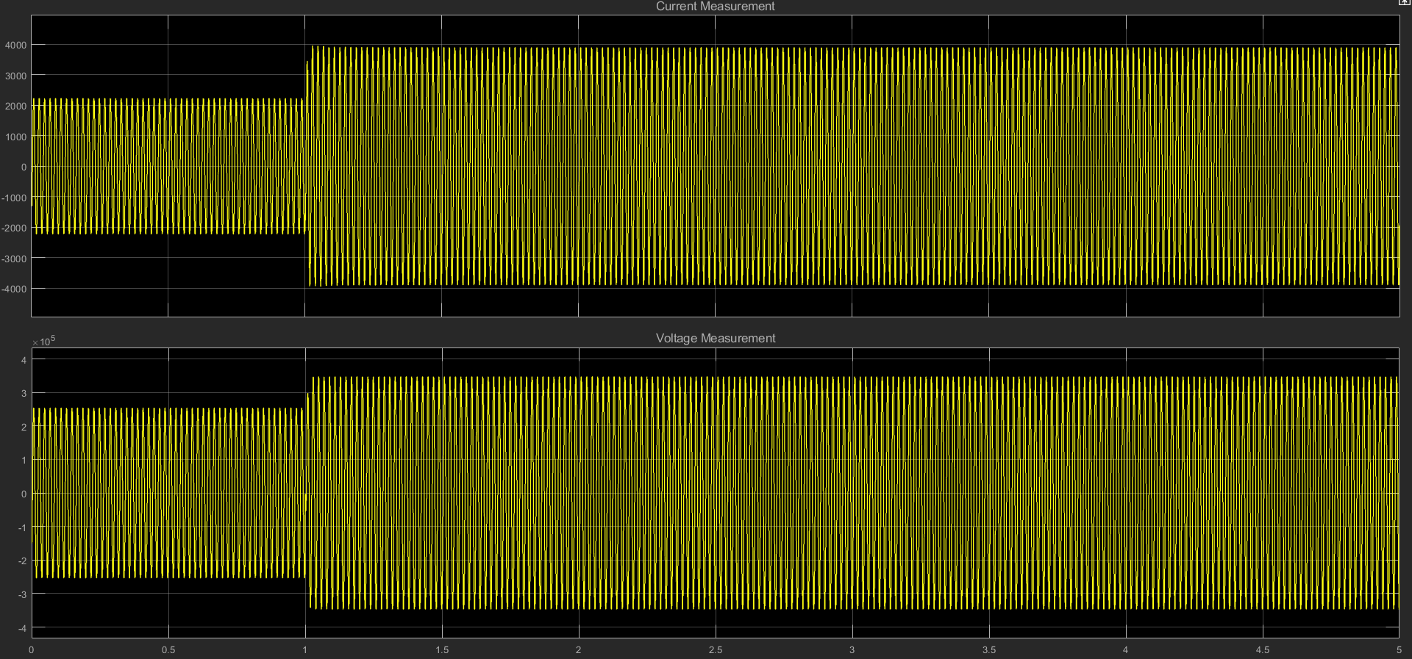

**WITHOUT CAPACITOR**

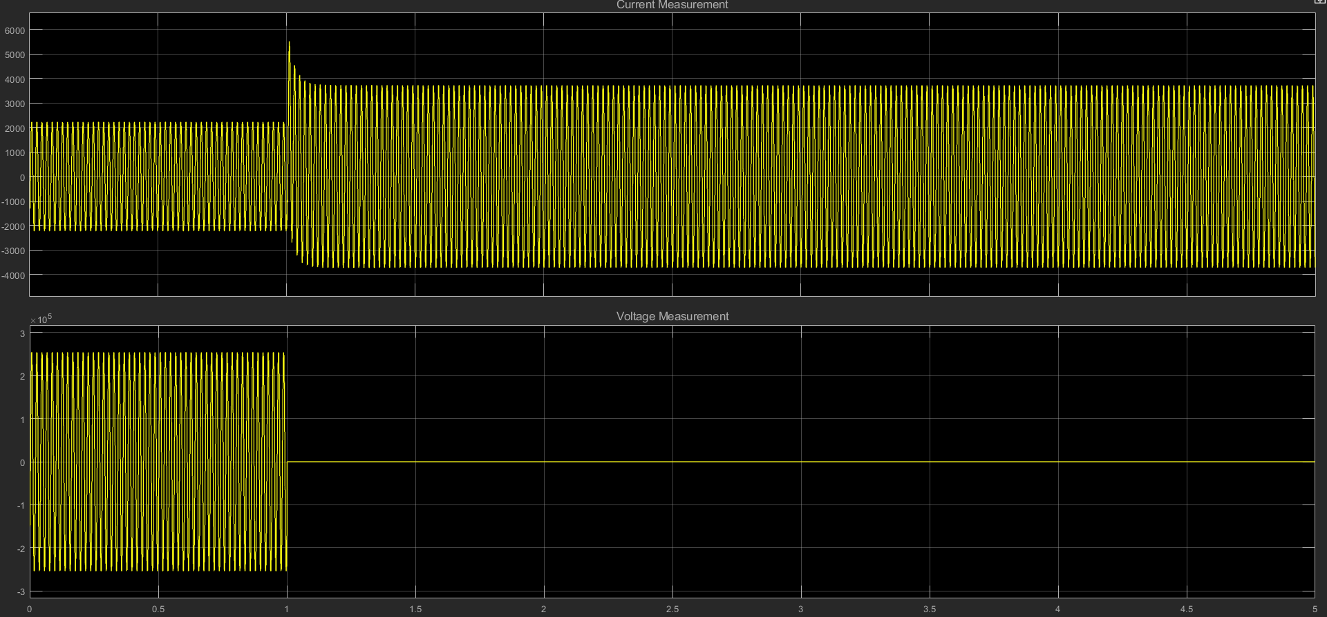

**4. VS = 252.2 KV**

**WITH CAPACITOR**

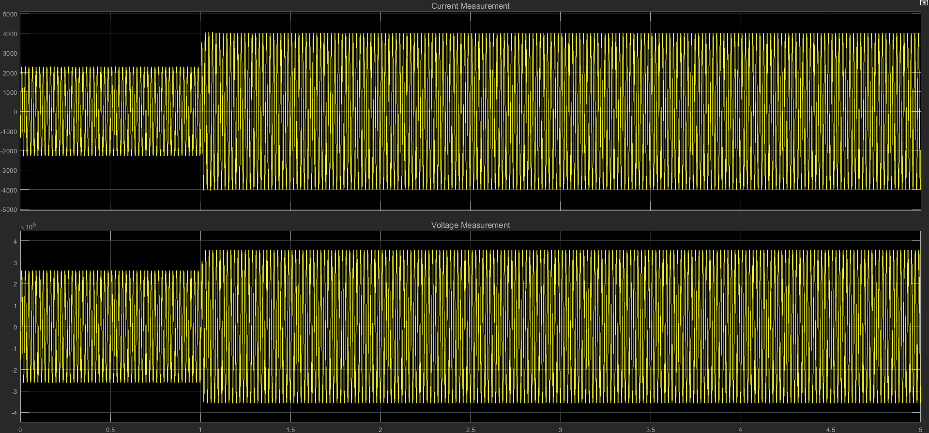

**WITHOUT CAPACITOR**

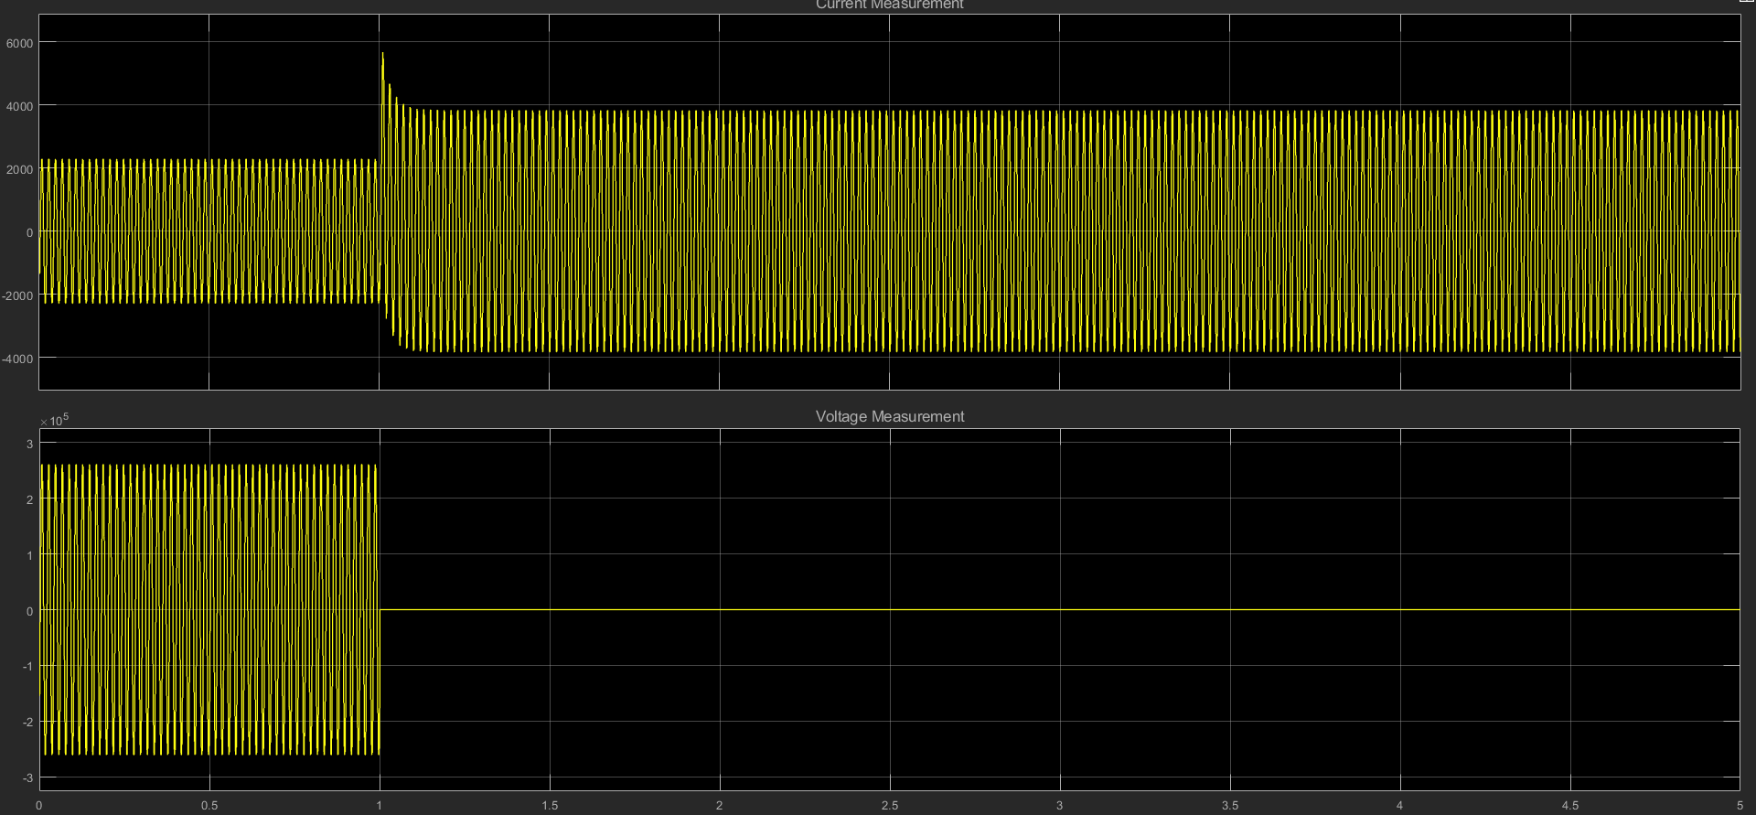

**5. VS = 259.2 KV**

**WITH CAPACITOR**

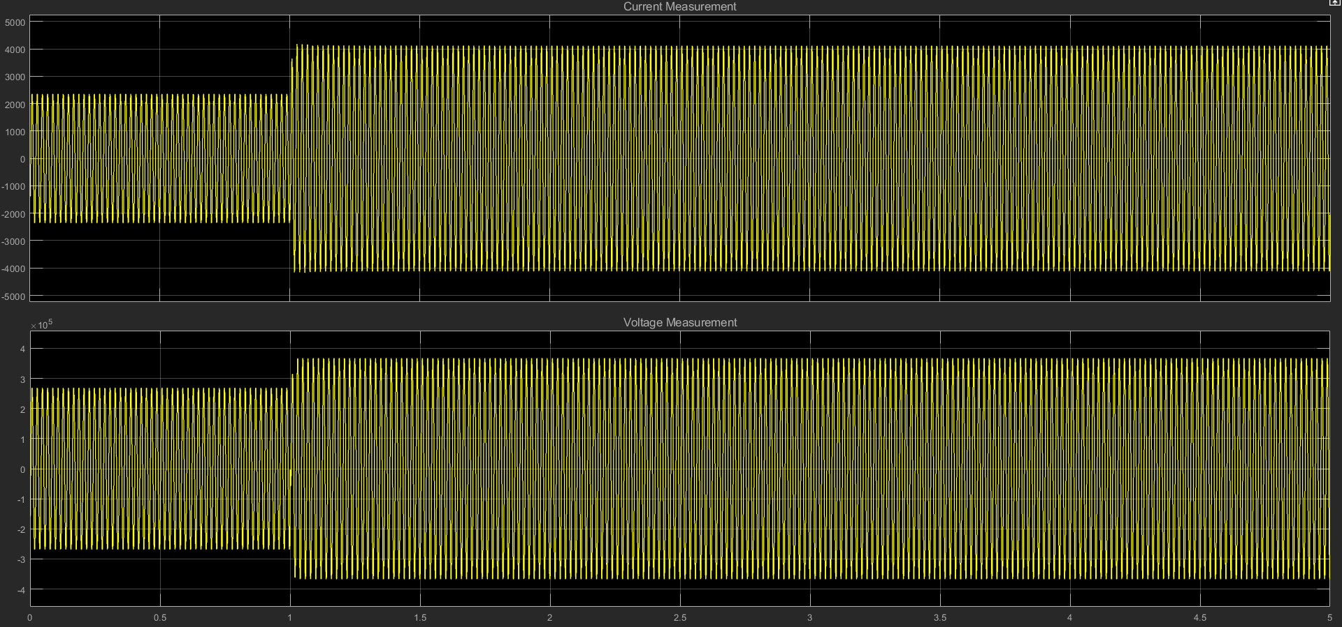

**WITHOUT CAPACITOR**

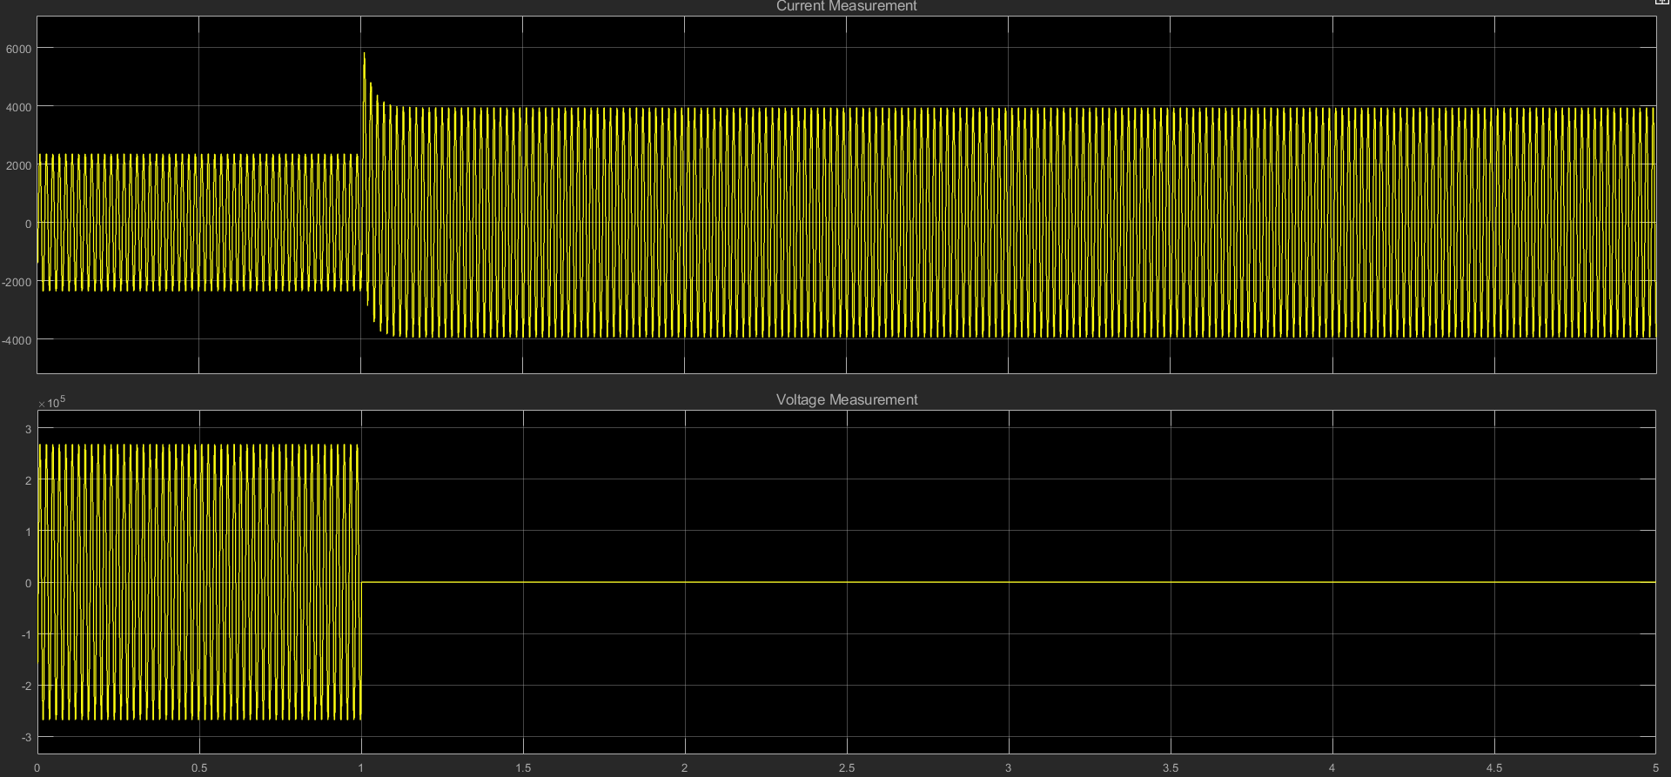

**Results**

Voltage profile of transmission line with and without shunt capacitor has been plotted.